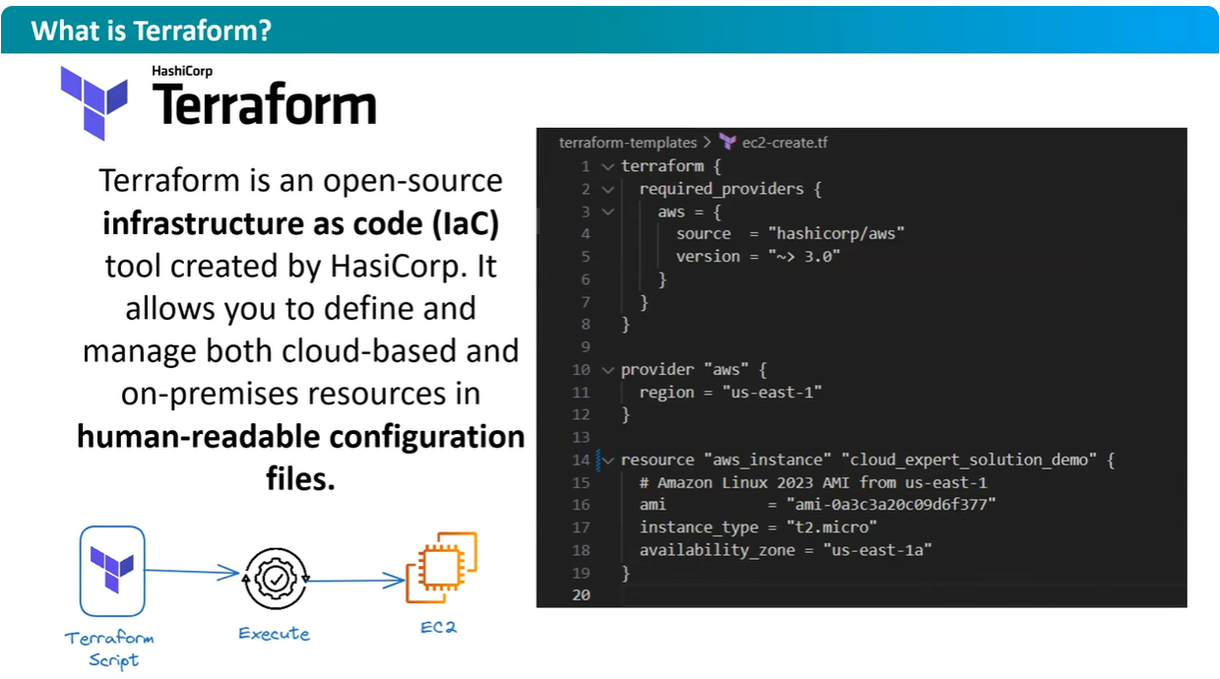

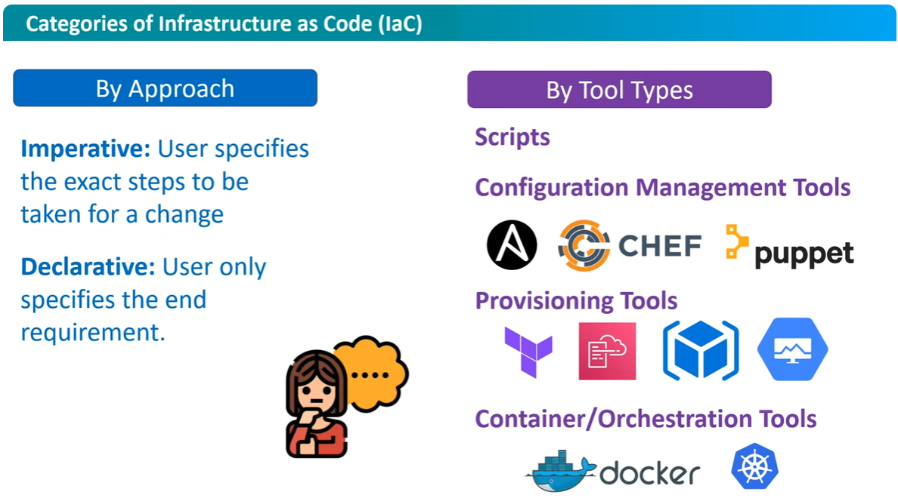

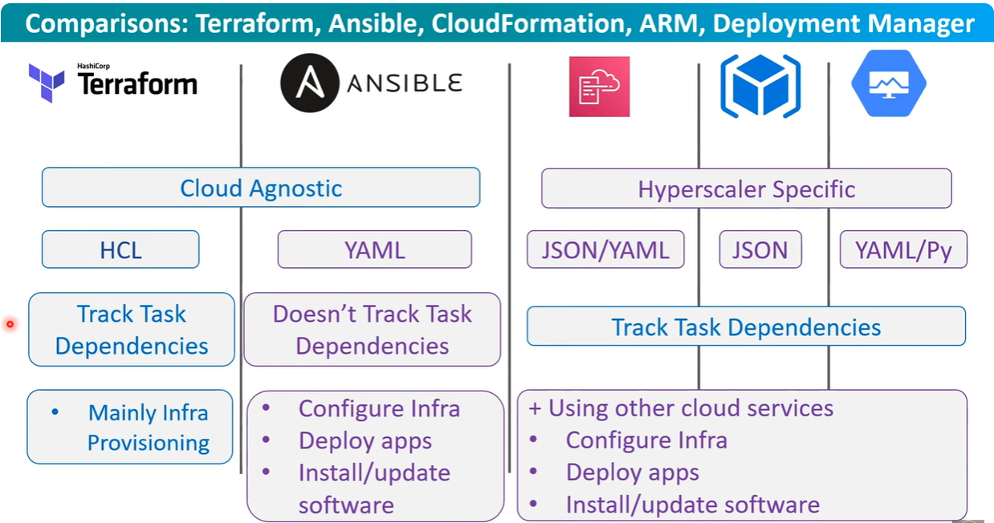

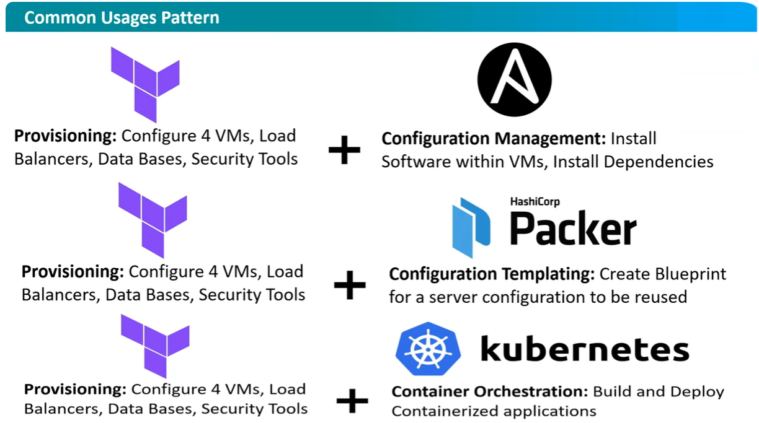

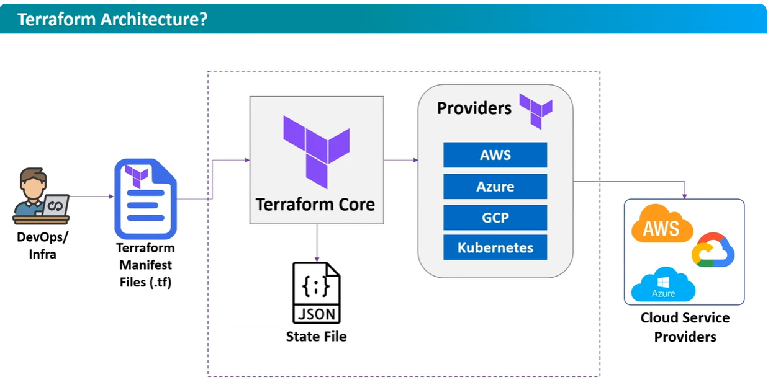

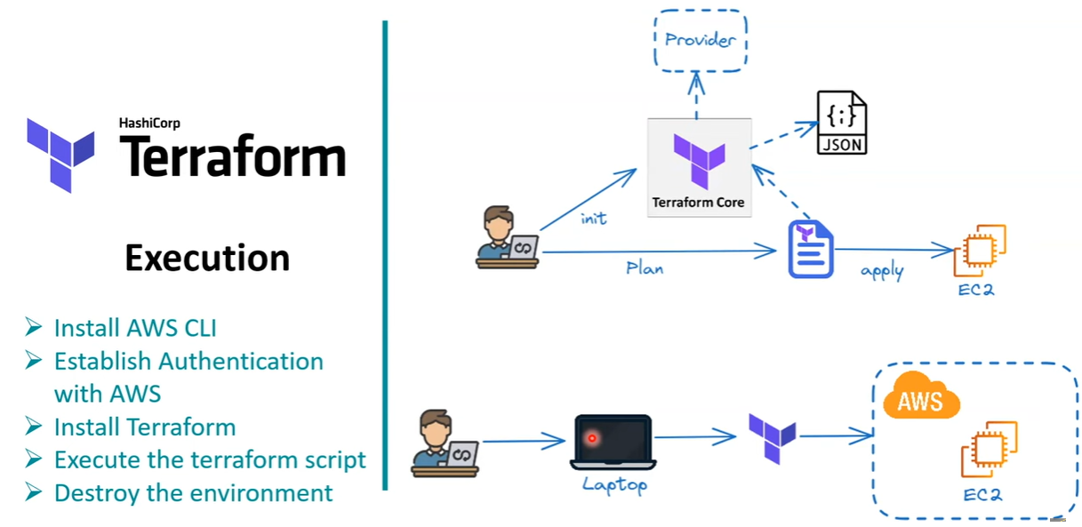

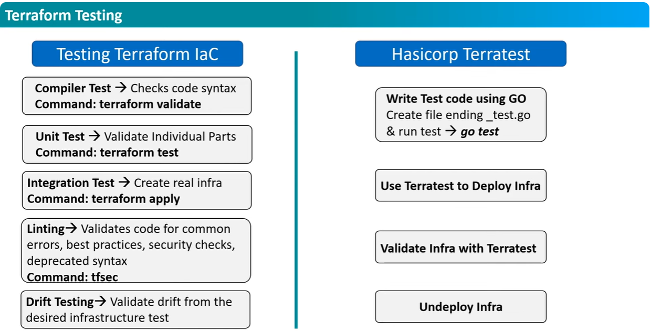

Terraform code to Launch AWS EC2 Instance.

mkdir terraform-scripts

cd terraform-scripts

sudo vim main.tf

#main.tf ---> Terraform Code to Launch AWS EC2 Instance.

terraform {

required providers {

aws = {

source = "hashicorp/aws"

version = "~> 3.0"

}

}

}

provider "aws" {

region ="us-east-1"

}

resouce "aws_instance" "cloud_expert_solution_demo" {

# Amazon Linux 2023 AMI from us-east-1

ami = "ami-0a3c3a20c09d6f377"

instance_type = "t2.micro"

availability_zone = "us-east-1a"

}

:wq!

terraform init ---> Terraform Initialization.

terraform plan ---> will give the instructions and details of required resouces to AWS provider to launch instance.

terraform apply ---> Executing the code to launch instance.

terraform destroy ---> To Remove / Terminate the Instance.

